

Sjoerd Halmans

Abstract

This research will dive into the different architectural possibilities for Productio

Productio research

Perfecting data management and security



# **Preface**

In this document I will be making a few research questions and answering them. The reason for this research document is me wanting to know more about the technology I am planning on using this semester and wanting to make sure I utilize the tools I have to the fullest.

The research will consist of one main question and a few sub-questions to further improve my ability to answer the main question. I will be using the CMD methods pack to categorize my research techniques. This way I can use triangulation to further support my research.

# Main question

To get this research started I have made one main question to answer, this question will be supported by different sub-questions. The main question is as follow:

**“What decisions can be made regarding microservice use within the project to improve it’s security and remove single points of failure”**

This is a large question to answer on it’s own. That is why I have also formulated a few sub-questions to answer it. These will be shown and answered in the pages below.

# Sub-question 1

The first sub-question is perhaps already the most important sub-question in the entire document depending on your view. This is as follow :

**“How do we to guarantee the safety of our data within the project”**

A hard question to answer indeed. But after a good amount of research I am happy to say I have come up with a conclusion on some of the things I can do to make sure my project is as secure as it can be. This will be explained in the lines below.

## Sub Question 1 research

To research this part of the application I used three research methods. I started with the library method ‘Design pattern search’. After doing this for a little while I came to the conclusion that using the different frameworks there are for the languages I plan on using would strongly improve the security for my application.

A strong contender is the spring cloud gateway. This will allow me to make a security checkpoint before any connection is made to any of the microservices. I plan on setting up one of these gateways and using it to make a secure connection to my different microservices.

Doing the above will help me secure my app. But to further the security I will make sure none of the microservices speak to each other, this could end up allowing a malicious connection between the two. Not doing this also helps me with eliminating single points of failure, but more on that later.

However, not every language I plan on using has the best security/I am not yet proficient enough in them. To make sure even these microservices stay secure most of the security will be done in the gateway, and if possible another framework will be used where possible in the different microservices. While this might mean more work for me, it does mean that the app will be secure and data leaks will be less likely.

To finish off this question I have decided that all sensitive data will be encrypted before entering the database. This means that data leaks have a lesser chance of actually leaking information.

## Sub Question 1 conclusion

To conclude the research on security, using different strong frameworks and a central authentication via auth0 and the gateway will allow for a strong authentication network

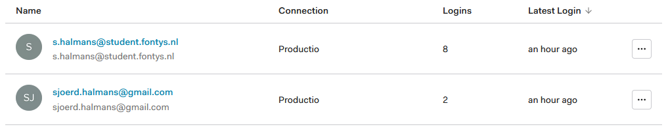

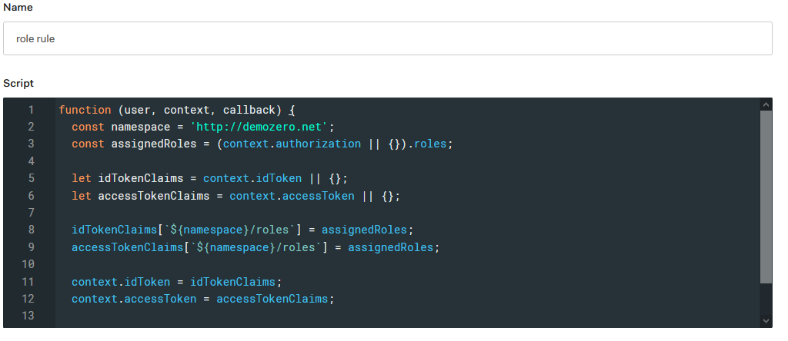

Further research will be done via prototypes and testing. For now I will create an authentication service with auth0 and different roles with permissions.